***Trajectory and character of oyster growth under altered total alkalinity and salinity***

1,2Saley, Alisha M., 2Kimball, Zoe & 1,2Brian Gaylord

1 Bodega Marine Laboratory, University of California Davis

2 Dept. of Ecology and Evolution, University of California at Davis

***Abstract—*** Sessile organisms in dynamic coastal and estuarine environments can experience both gradual transitions in seawater properties, as well as sudden, step-like changes that then persist for long periods. Seawater carbonate system parameters like total alkalinity (TA) and salinity are prime examples of parameters that vary in this fashion. Little is known, however, about how organisms experiencing such variation will respond over the course of an exposure. In particular, it remains unclear whether physiological responses to changes in TA and salinity manifest quickly or slowly, and whether such responses are transient or persist for extended periods. Understanding such details is essential to predicting how marine species might cope with increasingly perturbed shoreline environments. Here, we compare effects of a rapidly initiated but persisting modification to TA and salinity on growth of juvenile Eastern oysters (*Crassostrea virginica*). We explore responses across two time windows, one immediately after initiation of a treatment (days 0 – 18) and another that follows later (days 19 – 36). We employ six treatment levels of total alkalinity (spanning 792 to 2916 µmol kg-1) and two salinities (27 and 34) that might be expected within coastal zones or estuaries that receive stream inputs. In addition to assays of shell growth, we also examine consequences of altered TA and salinity for indices of shell thickness (mg mm-2) and oyster condition index (mg mg-1). Results demonstrate that growth in shell area of oysters was higher during the earlier time window compared to the later window. Growth in shell area was unaffected by TA in the earlier window, but increased with higher TA during the later window. Oyster individuals of larger initial size grew faster in the earlier time window. Salinity had no effect during either window. Over the full time period of the experiment spanning both time windows, neither shell thickness nor condition index varied with TA or salinity. The lack of trend over such a longer period resembles that observed in other well-fed calcifiers that increase energy expenditures to cope with stressful conditions, or that trade one axis of physiological response against another. This work begins to confront the need to consider temporal details and sensitivities of species to multiple types of altered seawater carbonate system parameters characteristic of nearshore habitats.

***Introduction—*** Coastal zones and estuaries exhibit variability in the seawater carbonate system, with implications for calcifying inhabitants. For example, biogeochemical processing and river inflows can create deviations in total alkalinity (TA) from open-ocean values (Hunt et al. 2011, Fassbender et al. 2016, Montagna et al. 2018). Likewise, salinities can be modulated (Hollarsmith et al. 2020). Shoreline and estuarine conditions are also temporally complex, with TA and salinity changing abruptly, often in conjunction with storms or seasonal shifts, and then persisting for days to months (Najjar et al. 2020, Ricart et al. 2021, Bartoloni et al. 2023). Such dynamics require that sessile calcifiers conform to new conditions and then endure them for sometimes extended durations. Given the multi-faceted extent to which seawater conditions dictate physiological and ecological performance of marine calcifiers (Hofmann and Todgham 2010, Gaylord et al. 2015), investigating responses to variation in TA and salinity deserves detailed attention.

Global perturbations to the carbonate system are likely to intersect with effects of variation in total alkalinity and salinity. Approximately a third of human-produced carbon dioxide emitted to the atmosphere absorbs into the oceans (Sabine et al. 2004). Changes to multiple components of the carbonate system of seawater ensue, causing ‘ocean acidification’ (Caldeira and Wickett 2003). Meanwhile, global warming is increasing the frequency and magnitude of extreme precipitation events, which can result in stronger reductions to salinity than normal. Thus, both small- and large-scale processes governing variation in TA and S operate within coastal areas and estuaries, and can impact the ability of shell-forming taxa to precipitate their calcium carbonate structures.

Substantial effort has documented how calcifier growth can be disrupted by an altered carbonate system, both within and across life stages (**cite** list). A subset of this work has emphasized effects of temporal characteristics of exposure (e.g., static versus fluctuating conditions, often of pH or CO2) (Mangan et al. 2017). However, gaps remain in our understanding of whether responses to sudden changes in the carbonate system manifest quickly or build up more slowly, and whether responses continue to hold or abate as perturbed conditions persist. Such “step change” exposures are not uncommon in nature, and their durations can differ across systems and localities. Therefore, information regarding the trajectory of calcifier responses across time is valuable. These points become especially relevant to dissecting potential physiological trade-offs in energy allocation – for example among growth (shell or tissue), reproduction, movement, and maintenance – each of which has its own time course and metabolic pathway (for example, see Kroeker et al. 2014).

Explorations of how growth rate responds to altered TA and S are especially suited to extending prior work. For example, extensive research has documented disrupted growth in bivalves under ocean acidification (for review see Gazeau et al. 2013, Shi and Li 2023), but few if any of these studies have deliberately examined effects of modifying TA. Similar limitations in experimental manipulation of TA apply to crustaceans and echinoderms, that have demonstrated variable and broad tolerance to OA conditions, respectfully (see reviews in Dupont et al. 2010, Whiteley 2011). Strong drops in salinity are likewise known to affect growth (Pourmozaffar et al. 2020). However, potential correlations between decreased salinity and TA may have unintentionally blurred the relative importance of these two factors in many such studies. Therefore, explicit tests of effects of TA and salinity on calcification abilities of coastal and estuarine taxa are needed.

Oysters have significant economic and ecological value to coastal populations of humans and wild organisms alike. Because many oyster species create structure-forming reefs, they often provide habitat for other estuarine taxa (Coen et al. 2007). Moreover, they help protect against shoreline erosion from waves (Wiberg et al. 2019). Commercially, when reared and harvested for human consumption, they contribute to a globally-expanding shellfish diet (Santeramo et al. 2017). In the latter context, relative and absolute amounts of shell and tissue mass become relevant.

Here we explore how total alkalinity and salinity affect growth of juvenile Eastern oysters (*Crassostrea virginica*), with special attention to the trajectory of response to step changes in seawater TA and salinity. In particular, we examine how growth in shell area differs between an earlier time window, starting immediately after initiating treatment conditions, and a later time window two weeks later. In these efforts we also account for the size of oysters at the beginning of each time window. At the end of the experiment, we additionally compare a metric of oyster shell thickness (shell mass per area) and condition index (tissue mass per shell mass) across different TA and salinity exposures. Examinations such as these lend insights into ways in which calcifying coastal and estuarine species may respond across time to abrupt and persisting changes in seawater carbonate chemistry.

***Methods—***

**Study species—** The Eastern oyster, *Crassostrea virginica*, is native to estuaries of eastern North America, from the Gulf of St. Lawrence to the Gulf of Mexico (**cite**). Due in part to its wide salinity and thermal tolerance, this species is also grown commercially elsewhere, including the west coast of the United States and Hawaii. For our experiments, we sourced juvenile oysters from a local aquaculture farm in Tomales Bay, California, USA (Hog Island Oyster Company; 38.162327, -122.893489). On 22 July 2022, we transported oysters in cool seawater from Tomales Bay to the University of California, Davis’ Bodega Marine Laboratory (BML; Bodega Bay, California, 60 min transit time), and placed them immediately into flow-through, continuously bubbled seawater drawn from the adjacent ocean. We fed the oysters with slow-release mixed algal diet (5% of their wet mass with thawed whole-cell concentrate of *Tetraselmis sp.*, *Thalassiosira* *weissflogii*, *Thalassiosira pseudonana*, and *Schizochytrium*; Reed Mariculture) once every two days, throughout a 30-d lab acclimation period. At the end of the acclimation period, we glued the oysters (left valve) to plastic plates using **X** marine epoxy (n = 49 per plate, n = 12 plates). We then returned the plates with attached oysters to the acclimation tanks, and three days hence began a 36-d growth experiment (Fig. 1).

**Design of experiment—** Our primary aim was to determine effects of total alkalinity on oyster shell growth. We established six treatment levels of TA, spanning conditions characteristic of estuaries with substantial rainwater input (low TA, 800-1500 umol kg -1), through more typical alkalinity conditions (intermediate TA, 2000 – 2200 umol kg -1), to conditions observed in estuaries supplied by watersheds of high-carbonate geology (high TA, > 2200 umol kg-1). Because streams and rivers that deliver low- to high-TA fresh water can simultaneously decrease estuarine salinity, we also established two treatment levels of salinity, an ambient level (S=34) and a reduced salinity level (S=27). The resultant experimental design linked treatments of both lower and higher TA with both low and ambient salinity. Although the treatment conditions were not fully orthogonal (Fig. 1), this design enabled exploration of independent effects of TA and salinity across a spectrum of environmental conditions relevant to *C. virginica*. Each TA and salinity treatment combination (6 total) was replicated across two static culture chambers, each containing one plate with 49 attached oysters. The overall configuration thus summed to 49 oysters x 2 cultures x 6 treatments = 588 oyster individuals across the experiment.

We were additionally interested in whether oysters might respond in a different way immediately following exposure to a novel set of TA and salinity conditions, compared to a response later on after the exposure had continued for multiple days. We therefore sampled growth in shell area at several time points throughout the 36-d experiment, focusing especially on growth across two time windows, one earlier (days 0-18) and one later (days 19-36).

**Oyster growth—**We tracked changes in shell surface area throughout the experiment, taking photos of shell area on day 0, day 18, and day 36. We analyzed the photos using ImageJ software (v.1.53t) to determine projected surface area of each oyster’s top valve, ensuring a scale bar was visible in each image. We quantified the growth in shell area (difference in shell area between start and end dates) within earlier and later windows, and the overall shell growth across the full 36 days of the experiment. We additionally measured condition index at day 36, which we quantified as dry tissue mass per dry shell mass, after separating the tissue from the shells and drying each at 60°C for 48 hr. We then divided shell mass by shell area to develop a rough metric of shell thickness.

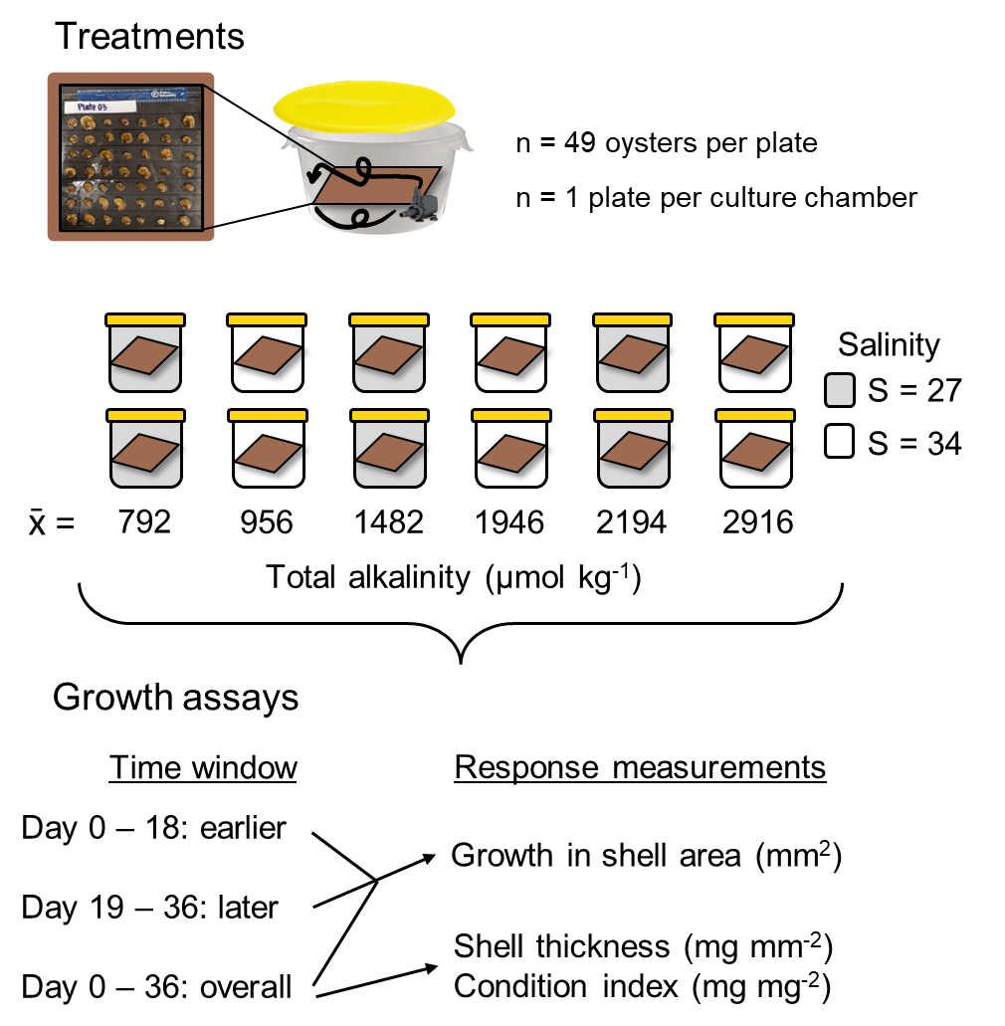

**A**

**B**

Fig. 1. Schematic of A) experimental culture conditions and B) growth responses that were measured through time. We employed six TA conditions and two salinity levels, replicating each TA-salinity combination. One oyster plate was assigned to each of the resulting 12 culture chambers for the 36-day experiment. We measured growth in shell area in an earlier and later window (days 0 - 18 versus days 19 - 36). We also measured overallshellgrowth across the full experimental period (36 days), and quantified shell thickness (mg mm-2) and condition index (mg mg-2) at the end of the experiment.

**Culture conditions—** Each static culture during the experiment included an aquarium pump to ensure adequate water motion. The continuous stirring allowed gas exchange at the water’s surface to keep oxygen levels at >80% saturation . The only exceptions were two cultures that dropped to ~70% on one occasion each, due to pump failure. The resulting episodes of decreased oxygen lasted less than 8 hr. Oysters were fed daily with shellfish mixed algal diet, and were held in the dark to minimize the influence of shadows on activity (cite). Complete water changes were done every three days, and the sides of the culture chambers, and pumps, cords, and tubing were cleaned of any fouling organisms and debris. The experimental cultures had lids but were not tightly sealed due to a gap created by the pump power cord, which resulted in minor chemical drift between water changes (Fig. 2). Despite this drift, chemical conditions across treatments remained distinct and differed statistically. Any mortality of oysters was recorded at the same time as water changes, and shells of deceased oysters were promptly removed from the cultures and discarded (< 15% mortality in any given culture chamber).

Before and after each water change during the experiment, we measured seawater temperature, salinity, pH, and dissolved oxygen concentration with a handheld multi-parameter sensor (YSI X). In 50% percent of pH measurements, we collected and analyzed discrete bottle samples for spectrophotometric determination of pH (calibrated on the same day with m-cresol dye standards, Easley and Byrne 2015), and used the latter data to translate pH data to the total scale. We also collected and immediately froze 250 ml seawater samples before and after each water change for later alkalinity determination. We quantified seawater TA in triplicate using a Metrohm 855 Titrosampler, correcting titration acid concentration daily with certified reference materials from the laboratory of Dr. Andrew Dickson (Scripps Institute of Oceanography). Finally, we used measurements of seawater TA (µmol kg-1) and pH (total scale) at specified salinities and temperatures to estimate the remaining seawater carbonate system parameters with the *seacarb* package in the software R (version 3.3.1). In our *seacarb* estimates, we used equilibrium constants from Lueker et al. 2000 (K1 and K2), Perez and Fraga 1987 (Kf), and Dickson 1990 (Ks). For simplicity, we refer to the seawater carbonate system in terms of TA, though additional carbonate system parameters vary in conjunction with shifts in alkalinity (Table S1), some of which may influence oyster growth separately from salinity and TA.

**Chemical manipulation of seawater—** Seawater chemical conditions at the beginning of the experiment and at each water change were established as follows. We first depleted seawater TA to negligible concentrations in large sumps (n = 4 sumps/water change) by adding hydrochloric acid (HCl) to drive the carbonate system reactions towards CO2, which then off-gassed over two days in conjunction with strong bubbling with air. We then mixed the TA-depleted seawater with distilled fresh water and premade solutions of NaHCO3 (sodium bicarbonate) and Na2CO3 (sodium carbonate) with HCl to adjust the carbonate system back to desired salinity and TA levels (Waldbusser et al. 2015, Ninokawa et al. in review).

[What is the symbol indicated along the y-axis of panel B? If it is an axis break, it should probably be removed. In the presence of an axis break and in the absence of additional y-axis values and tic marks, it becomes impossible to ascertain the magnitude of variation in the data points].

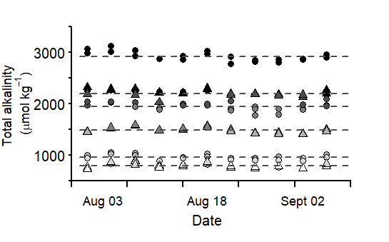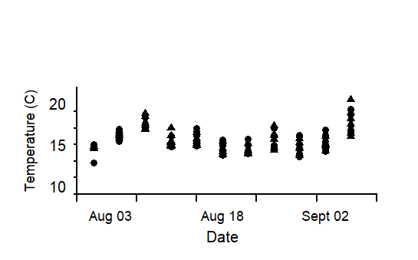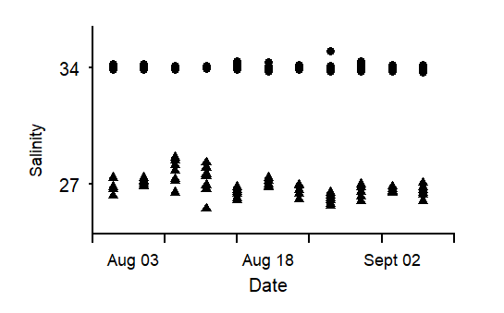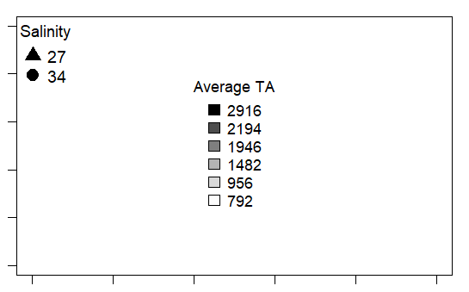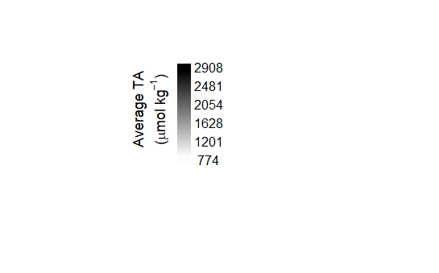

Fig. 2. Measured A) total alkalinity (TA), B) salinity, and C) temperature values for each culture chamber over the 36 days of the experiment. In panel A, dashed lines show the average TA value of replicate chambers (n = 2).

**ǁ**

**C**

**A**

**B**

**Statistical analysis—** All statistical tests were performed in R Studio (ver. 2022.07.02). We used a mixed effects model (*nlme*, *lme4*) to explore how TA affects growth in shell area over the course of an exposure, across two salinity levels, and as a function of initial oyster size. We explored growth responses during two temporal periods: an earlier response window (days 0-18), and a later response window (days 19-36). The initial size corresponded to the projected surface area at the beginning of the time window under consideration. Total alkalinity and initial oyster size were treated as continuous, fixed effects, whereas salinity (ambient versus low) and response window (earlier versus later) were included as categorical effects. We incorporated oyster individual and culture chamber as random intercepts to account for the lack of independence associated with repeated sampling of the same oysters and the lack of independence of oysters within a given culture. In the resulting analysis output, the effect of the earlier time window is considered the ‘default’, and as such, reported model estimates of the intercept and fixed effects (slopes) refer to effects within the earlier window. The effect of the second time window appears via the interaction terms between TA or salinity and the response window. We used similar models to test the influence of TA, salinity, and initial oyster size on overall growth over the full 36 days of the experiment. The influence of these latter three predictors on shell thickness (shell mass per area, mg mm-2) and condition index (tissue mass per shell mass, mg mg-2) were also tested, including culture chamber as a random intercept. We added a weighted variance term to models that failed the Breusch-Pagan test (*lmtest*) for residual heteroscedasticity, which specifies that the weight of each data point is equal to the proportional variance across bins. Assumptions of normality were visually assessed with qqplots and histograms of model residuals. We employed backwards step-wise model selection to test the effect size of parameters found significant in the model, running ANOVA comparisons between a full model and one with a given parameter omitted. The computed L-ratios, shown in Tables 1-4, indicate a proportional effect size relative to other predictors in the model, at a given p-value.

***Results—***

**Growth in shell area—** Growth in oyster shell area was higher during the earlier (0-18 d) response window than the later (19-36 d) response window (compare response scales between panels in Fig. 3). This difference was appreciable, with average oyster growth across all treatments during the second time window dropping from 11 to 2 mm2 compared to the first window, representing an almost ~80% decline. Total alkalinity did not influence growth in shell area during the earlier response window, but TA had a positive effect during the later response window (Fig. 3B; Table 1). The pattern during the later window may indicate that TA is more important in situations where rates of calcification of oysters are reduced by other factors. Salinity did not affect growth in shell area in either time window (Fig. 3, Table 1). In the earlier response window, there was a positive relationship between initial size and growth, while the relationship was reversed in the later window (Fig. 4, Table 1).

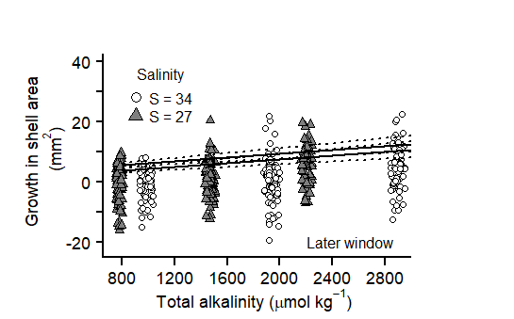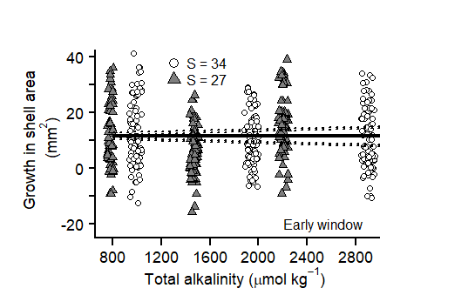

Fig. 3 Growth in shell area of juvenile *C. virginica* oysters during an A) earlier time window (days 0-18) and B) later time window (days 19-36) following initiation of treatment conditions. Growth in shell area depended on TA in the later window but not the first, and was not affected by salinity (grayscale). Model predicted intercepts and slopes (line) and SE borders (dashed line) were taken from a mixed-effects model, and therefore incorporate the effect of other model predictors (Table X).

**B**

**A**



Earlier window

Later window

**Overall shell growth, thickness, and condition index—** When overall growth spanning both time windows (i.e., over the full duration of the 36-d experiment) was computed, effects of TA were no longer apparent (Fig. 5, Table 2). Likewise, salinity did not influence growth in shell area after 36 days. However, the overall growth in shell area did increase with the initial size of oysters, similar to what occurred during the earlier of the two time windows (but not the later window). Neither shell thickness nor condition index, both assayed at the end of the experiment at day 36, showed an influence of total alkalinity or salinity (Fig. 6). However, oysters with larger initial shell areas tended to have a higher condition index. Shell thickness exhibited no trends as a function of initial oyster size.

.

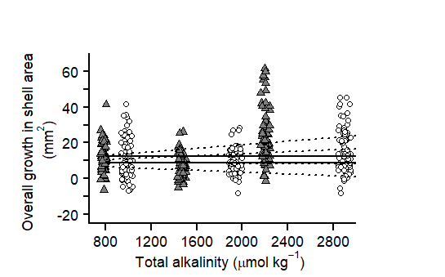

Fig. 5. Neither changes in total alkalinity (unit) nor salinity (greyscale) influence the overall growth in shell area (unit) of juvenile *C. virginica* oysters after 36 days of exposure to altered conditions. Intercept and slope model predictions (line) and SE borders (dashed lines) were taken from a mixed-effects model in Table X.

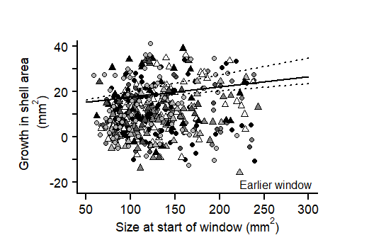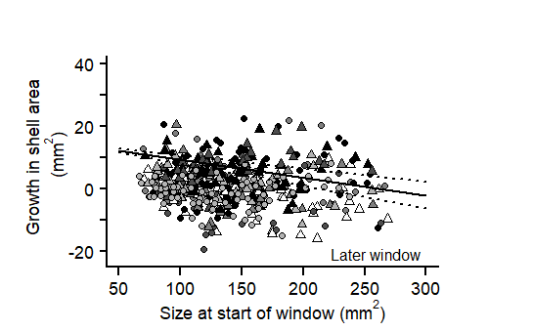

Fig. 4 Growth in shell area (mm2) exhibited different relationships with initial size between earlier (0-18 days) and later (19-36 days) exposure windows in juvenile *C. virginica* oysters. In the earlier window, growth was higher in larger oysters (black points), whereas larger oysters exhibited lower growth in the later window (grey points). Intercept and slope model predictions (line) and SE borders (dashed lines) were taken from a mixed-effects model in Table X.



**A**

**B**



Fig. 6. Neither changes in total alkalinity (µmol kg-1) nor salinity (greyscale) influence A) shell thickness (mg mm2) or B) condition index (mg mg2) of juvenile in *C. virginica* oysters.

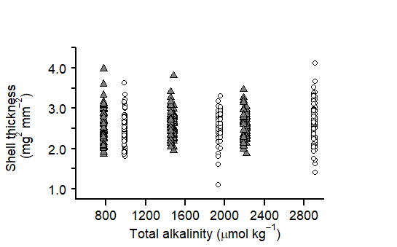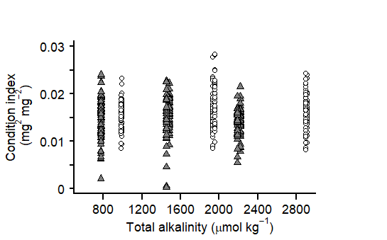

**A**

**B**

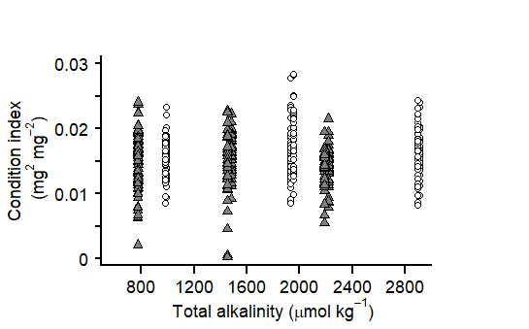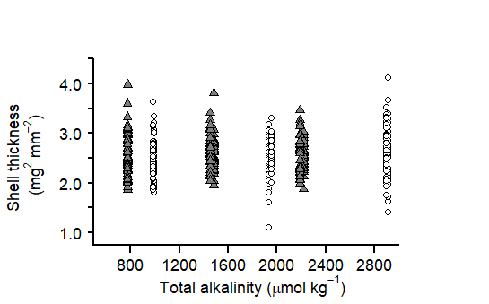

***Discussion—*** Growth in shell area of juvenile *C. virginica* oysters responded to altered alkalinity and salinity in a complex fashion. Greater increases in shell area during the first 18 days following imposition of treatment conditions, compared to days 19-36, suggested that oysters possess the physiological machinery to respond quickly but may rechannel energetic resources toward other body functions over time. A potential role for energy stores is further supported by the tendency for individuals of larger initial size to exhibit greater growth in shell area during the first time window. In contrast, effects of TA emerged in the second time window, perhaps in conjunction with diversion of energetic resources to other needs, or the depletion of those resources. Salinity did not affect growth in shell area during either time window, indicating lesser importance of this seawater parameter. Also notable is the finding that, over the course of the full 36 days, the above patterns combined to eliminate any effect of TA in overall shell growth. Similarly, there was no detectable consequences of low TA for shell thickness or condition index. Together, the obscuring of shorter-term patterns as time progressed is consistent with the hypothesis that early and late responses operated at least partially in opposition, resulting in a “canceling out” of effects of those responses over longer durations. That said, an influence of initial oyster size on overall growth and condition index remained apparent at day 36.

The apparent capability of Eastern oysters to acclimate quickly and grow new shell in low TA conditions applied even to seawater conditions that are corrosive to shell material. The two lowest TA treatments of our study were undersaturated with respect to calcite, the mineral form of calcium carbonate that comprises the majority of oyster shell. One possible explanation is that the oysters were able to compensate for shell loss due to dissolution because they were well fed, a trend that has been highlighted previously in a number of studies involving bivalves (cite). An alternative explanation is that higher shell growth arose in oysters that were initially larger in size due to increased surface area available as a substrate for additional calcification (cite). However, this concept appears less than fully likely given that the relationship disappeared in the later time window, implying that at least one relevant driver must have shifted in the second part of the experiment compared to the first.

In our experiments corrosive conditions arose due to low TA. Undersaturation can also derive from more classic ocean acidification scenarios. The latter causes elevated CO2 concentrations in seawater but leaves TA unchanged. However, both decreases in TA and increases in dissolved CO2 lead ultimately to a reduction in pH. Given that other coastal calcifiers have shown disruptions to shell growth under altered pCO2 conditions and decreased pH, it would be useful to test whether their sensitivity to corrosive seawater manifests under low TA even when pCO2 remains at modest levels.

As was mentioned above, declines in oyster shell growth during the later of the two time windows (days 19-36) coincided with an observed response to TA, and both growth effects and responses to TA could have arisen from the oysters diverting energetic resources towards physiological processes other than shell formation. Our data are unfortunately unable to offer insight into which, if any, alternative processes might have been prioritized. Follow-up experiments examining these issues could be informative.

Other calcifying species have demonstrated greater resistance to dissolution when the shell periostracum (an organic surface layer) is present that minimizes shell contact with the overlying seawater (cite). *C. virginica* oysters produce a periostracum. Although little is known about the effect of the periostracum on oyster shells, work by us with mussels has demonstrated a significant reduction in shell dissolution when this organic layer is present (see Chapter 1). Although the periostracum of Eastern oysters appears superficially rougher and thinner than in other bivalves, Zuykov et al (2012) measured low porosity in this covering, suggesting it may indeed retard contact of seawater with vulnerable nacre beneath it. In our study, although we did not measure periostracum coverage, we did note a strong discoloration in the shells through time as a function of TA condition (Fig 7). Such bleaching of the shell exterior may indicate periostracum loss and potentially even subsequent dissolution of surface shell. Future work may benefit from closer attention to the periostracum and its interaction with seawater TA.

After 36 days of exposure, there was no significant variation in oyster shell thickness or condition index in response to changes in TA or salinity, which may suggest that oyster shell growth occurred without a discernible energy trade-off. However, given that we were only able to assess shell thickness and condition index at the start and end of the experiment, and not at intermediate time points, there are multiple scenarios that could have led to the same result. For example, it is theoretically possible that oysters first directed resources toward expanding the surface area of their shells, at the expense of shell thickness and condition index. Then, once larger in shell area, the oysters could have redirected resources toward thickening their shells and bolstering their tissue mass. Such a mode of response would not be discernible in our data. This scenario may be somewhat unlikely given that other oyster studies have shown increases in both shell thickness and condition index in high-food environments (cite). Future research that decouples naturally shifting metabolic pathways from disruptions of altered seawater conditions in *C. virginica* and other calcifying species would be beneficial.

Although we observed no adverse impacts on shell growth with a salinity reduction to 27, it is worth considering that more severe declines in salinity, coinciding with forecasted extreme precipitation events, could interact differently with effects of TA.Especially along the Atlantic and Gulf coasts of the United States, where *C. virginica* provides vital habitat and economic services, hurricanes are becoming more frequent and severe (cite). Even along the U.S. West Coast where hurricanes are rarer, extreme precipitation events have resulted in mass mortality of native oyster populations, though *C. virginica* may be able to tolerate declines in salinity better than other related species (cite). The extent to which *C. virginica* oysters may be able to handle shifts in TA when coupled with more drastic reductions in salinity, like those corresponding to extreme storms, could provide insight into whether lower salinities have the potential to interact more strongly with variable TA than observed in our study.

Understanding the trajectory and character of growth responses of coastal and estuarine calcifiers to changes in TA and salinity remains an area for future exploration. Our results illustrate that effects of TA on oyster shell growth manifest in a complex manner that can change over time and likely operate in tandem with other environmental stressors. As more extreme changes to conditions continue to emerge, it will become increasingly important to understand how growth in oysters and other calcifiers responds to ongoing and future shifts.

***Tables—***

Table 1. Results of a mixed effects, linear regression model testing the independent effects of total alkalinity (TA), salinity (factor, 2 levels) and size at start of window (mm2) and their interaction with time window (factor, 2 levels) on growth in shell area (mm2) of juvenile *Crassostrea virginica* oysters. L-Ratios (for significant parameters) and p-values were recorded during backward stepwise model selection and refer to the ANOVA test output between the full model and a model with the specified predictor omitted. Bolded values denote a significant effect, determined by alpha < 0.05. The final model: Growth in shell area ~ total alkalinity + factor(salinity) + factor(time window) + initial size + interaction (TA: time window) + interaction (salinity + time window) + random intercept(individual) + random intercept(culture chamber), accounted for ~ **30**% of the variation. In model estimates below, the intercept refers to the effect of ambient salinity, whereas the salinity term refers to the effect of low salinity, both in the earlier time window. The TA term refers to the earlier window effect of total alkalinity, whereas the interaction term between TA and window describes the effect of TA in the later window. Similarly, the second interaction term, ‘Salinity: window’, describes the effect of salinity during the later window.

|  |  |  |  |  |  |  |
| --- | --- | --- | --- | --- | --- | --- |
| **Fixed Effects**  marg. r2 = 0.30  cond. r2 = 0.30 | **Estimate** | **Std. Error** | **t-value** | **df** | **L. Ratio** | **p-value** |
| Intercept | 1.7609 | 0.2019 | 8.7220 | 446 |  | **< 0.0001** |
| Salinity | -0.0091 | 0.0576 | -0.1586 | 446 |  | 0.8740 |
| Size at start of window | 0.0012 | 0.0004 | 2.7984 | 445 | 6.5126 | **0.0016** |
| Total alkalinity (TA) | 1.3900e-05 | 4.0090e-05 | 0.3478 | 446 |  | 0.7281 |
| Time window | -0.0653 | 0.0069 | -9.4658 | 445 |  | **< 0.0001** |
| Interaction (TA: window) | 0.0002 | 0.0001 | 3.5412 | 445 | 12.5400 | **0.0004** |
| Interaction (Salinity: window) | 0.1855 | 0.0814 | 2.2796 | 445 | 5.1965 | 0.2294 |
| **Random Effects** | **Intercept** | **Residual** |  |  | **L. Ratio** | **p-value** |
| Individual | 2.1804e-05 | 0.5762 |  |  | 6.3379e-07 | 0.9994 |
| Culture chamber | Add | Add |  |  | Add | add |

Table 2. Results of a mixed effects, linear regression model testing the independent effects of total alkalinity (TA), salinity (factor, 2 levels) and initial size (mm2) on overall shell growth (mm2) in juvenile *Crassostrea virginica* oysters after 36 days. L-Ratios (significant parameters) and p-values were recorded during backward stepwise model selection and refer to the ANOVA test output between the full model and a model with the specified predictor omitted. Bolded values denote a significant effect, determined by alpha < 0.05. The final model: Overall shell growth ~ total alkalinity + factor(salinity) + initial size + random intercept(culture chamber), accounted for ~ **X**% of the variation. In model estimates below, the intercept refers to the effect of ambient salinity, whereas the salinity term refers to the effect of low salinity.

|  |  |  |  |  |  |  |
| --- | --- | --- | --- | --- | --- | --- |
| **Fixed Effects**  marg. r2 = 0.16  cond. r2 = 0.52 | **Estimate** | **Std. Error** | **t-value** | **df** | **L. Ratio** | **p-value** |
| Intercept | -0.0743 | 0.1611 | -0.4615 | 436 |  | 0.6447 |
| Salinity | 0.0743 | 0.1060 | 0.7009 | 9 |  | 0.5011 |
| Initial size | 0.0020 | 0.0002 | 8.9071 | 436 |  | **< 0.0001** |
| Total alkalinity | 0.0001 | 0.0001 | 1.4194 | 9 |  | 0.1895 |
| **Random Effects** | **Intercept** | **Residual** |  |  | **L. Ratio** | **p-value** |
| Culture chamber | 0.1681 | 0.1956 |  |  | 95.48962 | **< 0.0001** |

Table 3. Results of a mixed effects, linear regression model testing the independent effects of total alkalinity (TA), salinity (factor, 2 levels) and initial size (mm2) on shell thickness (mg mm2) in juvenile *Crassostrea virginica* oysters after 36 days. L-Ratios (significant parameters) and p-values were recorded during backward stepwise model selection and refer to the ANOVA test output between the full model and a model with the specified predictor omitted. Bolded values denote a significant effect, determined by alpha < 0.05. The final model: Shell thickness ~ total alkalinity + factor(salinity) + initial size + random intercept(culture chamber), accounted for ~ **X**% of the variation. In model estimates below, the intercept refers to the effect of ambient salinity, whereas the salinity term refers to the effect of low salinity.

|  |  |  |  |  |  |  |
| --- | --- | --- | --- | --- | --- | --- |
| **Fixed Effects**  marg. r2 = 0.01  cond. r2 = 0.01 | **Estimate** | **Std. Error** | **t-value** | **df** | **L. Ratio** | **p-value** |
| Intercept | 2.4040 | 0.0803 | 29.9037 | 436 |  | **< 0.0001** |
| Salinity | 0.0355 | 0.0394 | 0.9002 | 9 |  | 0.3915 |
| Initial size | 0.0006 | 0.0004 | 1.3511 | 436 |  | 0.1774 |
| Total alkalinity | 4.4500e-05 | 2.7460e-05 | 1.6220 | 9 |  | 0.1392 |
| **Random Effects** | **Intercept** | **Residual** |  |  | **L. Ratio** | **p-value** |
| Culture chamber | 0.01 | 0.01 |  |  | 0.0130 | 0.9091 |

Table 4. Results of a mixed effects, linear regression model testing the independent effects of total alkalinity (TA), salinity (factor, 2 levels) and initial size (mm2) on condition index (mg mg-2) in juvenile *Crassostrea virginica* oysters after 36 days. L-Ratios (significant parameters) and p-values were recorded during backward stepwise model selection and refer to the ANOVA test output between the full model and a model with the specified predictor omitted. Bolded values denote a significant effect, determined by alpha < 0.05. The final model: Condition index ~ total alkalinity + factor(salinity) + initial size + random intercept(culture chamber), accounted for ~ **X**% of the variation. In model estimates below, the intercept refers to the effect of ambient salinity, whereas the salinity term refers to the effect of low salinity.

|  |  |  |  |  |  |  |
| --- | --- | --- | --- | --- | --- | --- |
| **Fixed Effects**  marg. r2 = 0.15  cond. r2 = 0.28 | **Estimate** | **Std. Error** | **t-value** | **df** | **L. Ratio** | **p-value** |
| Intercept | 0.0262 | 0.0042 | 6.1850 | 436 |  | **< 0.0001** |
| Salinity | -0.0035 | 0.0027 | -1.3166 | 9 |  | 0.2205 |
| Initial size | 0.0001 | 1.1252e-05 | 8.5433 | 436 | 69.7660 | **< 0.0001** |
| Total alkalinity | 1.3980e-05 | 1.8430e-06 | 0.7583 | 9 |  | 0.4677 |
| **Random Effects** | **Intercept** | **Residual** |  |  | **L. Ratio** | **p-value** |
| Culture chamber |  |  |  |  | 33.7828 | **< 0.0001** |